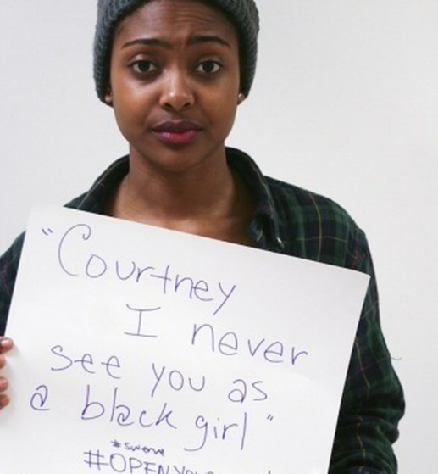
Unmasking Microaggressions: The Destructive Consequences of Unintentional Acts

On: Saturday | September 29, 2018
When: 10 AM – 12 PM
Where: First Evangelical Lutheran Church | 900 Main Street
(Rear Entrance) Brockton, MA
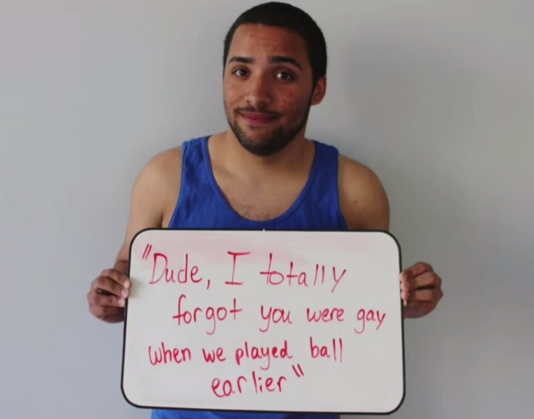
This workshop will look at the destructive consequences of small acts on people groups, and within the mental health setting. Following this workshop you will be able to 1. Provide a definition of microaggressions, 2. Provide examples of microaggressions in every day situations and within the field of mental health, 3. Understand the consequences of microaggressions for those on who find themselves on the receiving end of those behaviors, 4. Show increased awareness and cultural competence of own biases and identify ways for moving forward personally as well as in one’s clinical practice.

About the presenters: Brad Thorne is a licensed mental health counselor and nationally board certified counselor with over 30 years of clinical experience. He is the Director of the Brickley Center at Eastern Nazarene College where he has co-led presentations on microaggressions to college and university faculty and the Association for Christians in Student Development.
Lauren Thorne graduated in May 2018 with a bachelor’s degree in Sociology and Criminal Justice and is considering pursuing a law degree.
_______________________________________________________________________________________________________
Brought to you by PASTORAL COUNSELING SERVICES OF THE SOUTH SHORE. This training offers 2 continuing education units (CEU’s) for licensed therapists who meet criteria. The American Association of Pastoral Counselors (AAPC) has approved this program and has been approved by NBCC as an Approved Continuing Education Provider.

Cost: $30 if you register by September 24, 2018 | $50 at the door

Register by sending a check payable to ISLP with your name, address, phone and email information to: Institute for Spiritual Life and Psychotherapy PO Box 2306 Hanover, MA 02339. You may also register by calling us at 781-826-0011 x108 or x112.

